**A**

**PROJECT REPORT**

**ON**

**INVENTORY MANAGEMENT SYSTEM**

**SUBMITTED BY**

JHAVERI AARYAN K.

PALA VIRAJ V.

**ACADEMIC YEAR 2022-23**

**T.Y B.C.A. SEM - 6**

**UNDER THE GUIDANCE OF**

MR. SHAUNAK PUROHIT & MS. SANDHYA KAMADIA

**SMT. C.Z.M GOSRANI B.C.A. COLLEGE**

**JAMNAGAR**

**SUBMITTED TO**



**SAURASHTRA UNIVERSITY**

**RAJKOT**

**A**

**PROJECT REPORT**

**ON**

**INVENTORY MANAGEMENT SYSTEM**

**SUBMITTED BY**

JHAVERI AARYAN K.

PALA VIRAJ V.

**ACADEMIC YEAR 2022-23**

**T.Y B.C.A. SEM - 6**

**UNDER THE GUIDANCE OF**

MR. SHAUNAK PUROHIT & MS. SANDHYA KAMADIA

**SMT. C.Z.M GOSRANI B.C.A. COLLEGE**

**JAMNAGAR**

**SUBMITTED TO**



**SAURASHTRA UNIVERSITY**

**RAJKOT**



# **ABSTRACT**

Inventory Management System (IMS) is a GUI based web application useful for the business to manage their inventories.

Currently, some people are maintaining their inventory manually and some people are using the software which is difficult to use because it doesn’t have a user-friendly interface.

Main objective of IMS is to provide user-friendly GUI interface which can be made with minimal time and less effort and can be accessible without the internet connection.

# **ACKNOWLEDGEMENT**

We feel great pleasure in submitting this project report as a part of our B.C.A. Semester 6 curriculum. A practical study plays an important role.

For the successful completion of our project, we would especially like to thank our parents for their support and unconditional help. We would also like to thank our Project Guide Mr. Shaunak Purohit and Ms. Sandhya Kamadia for their constant support and help in implementation of this project.

We are also thankful to our Principal Ma'am, Ms. Hetal G. Savla for all the facilities they provided throughout our semester and for encouraging us to take up this activity.

Lastly, we would also like to thank the faculties and staff members of Smt. C.Z.M. Gosrani B.C.A. College, Jamnagar.

# **PROJECT PROFILE**

|  |  |  |
| --- | --- | --- |
| STUDENT INFORMATION | | |
| Name  Jhaveri Aaryan K.  Pala Viraj V. | **Enrollment Numbers**  00320320835  00320320871 | |
| PROJECT DETAILS | | |
| Project Title | Inventory Management System | |
| Duration | 4 Months | |
| Name of Project | DigiFirm | |
| Platform | Python  MySQL | |
| Team Size | 2 | |
| GUIDE INFORMATION | | |
| Name of Guide | | Mr. Shaunak Purohit  Ms. Sandhya Kamadia |

# **INDEX**

|  |  |  |
| --- | --- | --- |
| Chapter | Title | Page No. |
| 1 | **Overview of the accepted SDLC Model** | 1 |
| 2 | **Requirement Gathering and Analysis** | **2** |
|  | 2.1 Organization Details | 2 |
| 2.2 Meetings |
| 2.3 Type of Project | 3 |
| 2.4 Method of collecting requirements |
| 3 | **System Requirement Specification** | **4** |
|  | 3.1 Introduction | 4 |
| 3.1.1 Purpose |
| 3.1.2 Scope |
| 3.1.3 Operating Environment |
| 3.1.4 User classes | 5 |
| 3.2 System Modules |
| 3.3 External Interface Requirements | 7 |
| 3.3.1 Hardware Interface Requirements |
| 3.3.2 Software Interface Requirements |
| 3.3.3 User Interface Requirements |  |
| 3.4 Non-functional Requirements |  |
| 3.4.1 Performance Requirements | 7 |
| 3.4.2 Security Requirements | 8 |
| 4 | **System Analysis and Modelling** | **9** |
|  | 4.1 Normalization | 9 |
| 4.2 Data Dictionary | 13 |
| 4.3 Data Flow Diagram | 14 |
| 4.4 E-R Diagram | 18 |
| 4.5 Use-case Diagram | 19 |
| 4.5 Gantt Chart | 21 |
| 5 | **Test Cases** | **22** |
| 6 | **Screenshots** | **28** |
| 7 | **Limitations and Future Enhancements** | **33** |
| 8 | **Conclusion** | **34** |
| 9 | **References and Bibliography** | **35** |

**CHAPTER 1**

**OVERVIEW OF THE ACCCEPTED SDLC MODEL**

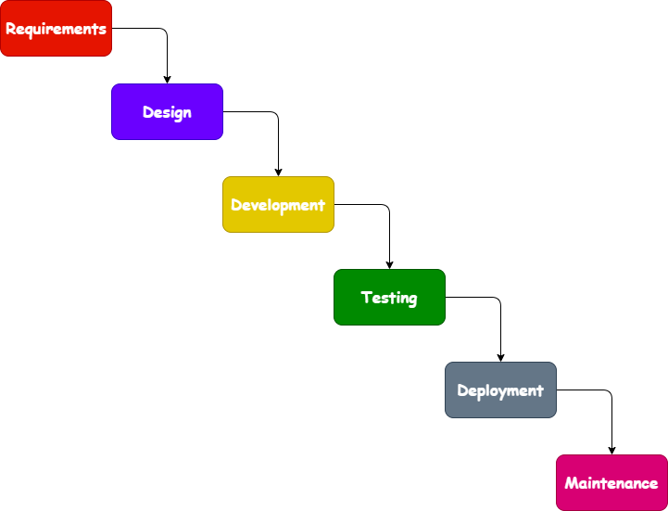

**Waterfall Model**

* Each step of the SDLC lifecycle is followed in a linear approach.
* Upon the completion of the step, next step is started.
* Cannot go to the previous step.

**CHAPTER 2**

**REQUIREMENT GATHERING AND ANALYSIS**

1. **Organization details**
   * **Name of organization:**
     + Pixel Solutions
   * **Brief details of the organization:**
     + Pixel Solutions is a reputed software development company. They’ve been operating since the year 2001.
2. **Meetings**
   * **Meeting with an Owner:**
     + **Name of the Owner:**
       - Mr. Rohan Shah
     + **Requirements of the owner in their own words:**
       - There should be 2 types of users i.e., Admin and Employee.
       - There should be one stop solution for the admin to manage the whole inventory of the company.
       - Employees should be able to make invoice by login their allotted credentials.
3. **Type of project**
   * The system will be in the form of a GUI Web Application and accessible without the Internet Connection.
4. **Method of collecting requirements**
   * The requirements of the system will be collected by interviewing the owner and user of the proposed system.

**CHAPTER 3**

**SYSTEM REQUIREMENT SPECIFICATION**

* 1. **Introduction**
* **Inventory Management System** is a GUI based web application that helps the owner to manage the whole inventory of the company and allows the employee to make the invoices.
  + 1. **Purpose**
  + The main purpose of this system is to provide an user friendly interface to the organizations to manage their inventory digitally.
    1. **Scope**
       - This system will be used by the Pixel Solutions and can be used by any organizations.
    2. **Operating Environment**
       - **Admin-side requirements:**
* Operating System: Windows 7 or higher
* Memory: 2 GB or higher
* Storage: 64 GB or higher
* Server Software: Python and MySQL
* **Employee-side requirements:**
* Operating System: Windows 7 or higher
* Memory: 2 GB or higher
* Storage: 64 GB or higher
* Server Software: Python and MySQL
  + 1. **User Classes**
       - **Administrators**
         * Can add, update and remove employees, suppliers, categories, products and other administrators.
         * Can make, modify and delete all the invoices.
       - **Employees**
         * Can make invoices of the products which are added by the administrator.
  1. **System Modules**
     + **Authentication**
       - Admins and Employees can login into the system by entering proper credentials.
     + **Manage Employees**
       - Available to only administrators.
       - Administrators can view, add, update and delete employees.
* **Manage Suppliers**
* Available to only administrators.
* Administrators can view, add, update and delete suppliers.
* **Manage Categories**
* Available to only administrators.
* Administrators can view, add, update and delete product categories.
* **Manage Products**
* Available to only administrators.
* Administrators can view, add, update and delete products.
* **Manage Invoices**
* Available to only administrators.
* Administrators can view, make, modify and delete invoices.
* **Manage Other Administrators**
* Available to only administrators.
* Administrators can view, add, update and delete other administrators.
  1. **External Interface Requirements** 
     1. **Hardware Interface Requirements**
        + 512 MB+ RAM
        + Keyboard and Mouse
        + 1.0+ GHz Processor
        + Monitor
     2. **Software Interface Requirements**
        + Operating System: Microsoft Windows 7 or Above
        + Front End Tools: Python, Tkinter
        + Back End Tools: MySQL
     3. **User Interface**
        + Admins can add the employees and other admins. Once the admin adds employees and other admins in the database, he/she can login by the provided credentials.
  2. **Non-functional Requirements**
     1. **Performance Requirements**
* Overall system should be fast, secure, error-free and user friendly.
* It should have a built-in calculator.
* The system should be able to handle large amounts of data.
  + 1. **Security Requirements**
       - User must have proper permission to perform tasks.
       - Administrators has more rights than employees.

**CHAPTER 4**

**SYSTEM ANALYSIS AND MODELLING**

* 1. **Normalization**
* It is the process of reducing the redundancy of data in the table and also improving the data integrity.
  + 1. **D-Normalization Form**

|  |  |
| --- | --- |
| Email | Password |
| abc@xyz.com | Aar@123 |
| def@xyz.com | Vir@123 |

* + 1. **1st Normalization Form**
  + **category**

|  |
| --- |
| name |
| Mobile |
| Laptop |
| Tablet |

* + **employee**

|  |  |  |  |  |  |  |
| --- | --- | --- | --- | --- | --- | --- |
| name | email | gender | contact | dob | doj | password |
| Aaryan | abc@xyz.com | Male | 1234567890 | 19/11/2002 | 18/11/2020 | Aar@123 |
| Viraj | def@xyz.com | Male | 0987654321 | 21/02/2002 | 20/02/2020 | Vir@123 |
| Heer | ghi@xyz.com | Male | 1478523690 | 15/02/2003 | 14/02/2021 | Hee@123 |

|  |  |  |
| --- | --- | --- |
| utype | address | salary |
| Admin | Jamnagar | 100000 |
| Admin | Jamnagar | 100000 |
| Employee | Jamnagar | 55000 |

* + **product**

|  |  |  |  |  |  |
| --- | --- | --- | --- | --- | --- |
| category | supplier | name | price | qty | status |
| Mobile | Aaryan | Samsung M53 | 24000 | 146 | Active |
| Laptop | Viraj | Dell G95 | 80000 | 97 | Active |
| Tablet | Heer | Samsung A8 | 17000 | 48 | Inactive |

* + **supplier**

|  |  |  |
| --- | --- | --- |
| name | contact | descr |
| Aaryan | 1234567890 | 150 units of Samsung M53 Mobile |
| Viraj | 0987654321 | 100 units of Dell G95 Laptop |
| Heer | 1478523690 | 50 units of Samsung A8 Tablet |

* + 1. **2nd Normalization Form**
  + **category**

|  |  |
| --- | --- |
| cid | name |
| 1 | Mobile |
| 2 | Laptop |
| 3 | Tablet |

* + **employee**

|  |  |  |  |  |  |  |
| --- | --- | --- | --- | --- | --- | --- |
| eid | name | email | gender | contact | dob | doj |
| 1 | Aaryan | abc@xyz.com | Male | 1234567890 | 19/11/2002 | 18/11/2020 |
| 2 | Viraj | def@xyz.com | Male | 0987654321 | 21/02/2002 | 20/02/2020 |
| 3 | Heer | ghi@xyz.com | Male | 1478523690 | 15/02/2003 | 14/02/2021 |

|  |  |  |  |
| --- | --- | --- | --- |
| password | utype | address | salary |
| 1234567890 | Admin | Jamnagar | 100000 |
| 0987654321 | Admin | Jamnagar | 100000 |
| 1478523690 | Employee | Jamnagar | 55000 |

* + **product**

|  |  |  |  |  |  |  |
| --- | --- | --- | --- | --- | --- | --- |
| pid | category | supplier | name | price | qty | status |
| 1 | Mobile | Aaryan | Samsung M53 | 24000 | 146 | Active |
| 2 | Laptop | Viraj | Dell G95 | 80000 | 97 | Active |
| 3 | Tablet | Heer | Samsung A8 | 17000 | 48 | Inactive |

* + **supplier**

|  |  |  |  |
| --- | --- | --- | --- |
| sid | name | contact | descr |
| 1 | Aaryan | 1234567890 | 150 units of Samsung M53 Mobile |
| 2 | Viraj | 0987654321 | 100 units of Dell G95 Laptop |
| 3 | Heer | 1478523690 | 50 units of Samsung A8 Tablet |

* + 1. **3rd Normalization Form**
  + **category**

|  |
| --- |
| cid |
| 1 |
| 2 |
| 3 |

* + **employee**

|  |
| --- |
| eid |
| 1 |
| 2 |
| 3 |

* + **product**

|  |
| --- |
| pid |
| 1 |
| 2 |
| 3 |

* + **supplier**

|  |
| --- |
| sid |
| 1 |
| 2 |
| 3 |

* 1. **Data Dictionary**
     1. **category**

|  |  |  |  |
| --- | --- | --- | --- |
| Sr. No. | Column | Type | Null |
| 1 | cid (Primary) | int(20) | No |
| 2 | name | varchar(255) | Yes |

* + 1. **employee**

|  |  |  |  |
| --- | --- | --- | --- |
| Sr. No. | Column | Type | Null |
| 1 | eid (Primary) | int(20) | No |
| 2 | name | varchar(255) | Yes |
| 3 | email | varchar(255) | Yes |
| 4 | gender | varchar(255) | Yes |
| 5 | contact | varchar(255) | Yes |
| 6 | dob | varchar(255) | Yes |
| 7 | doj | varchar(255) | Yes |
| 8 | password | varchar(255) | Yes |
| 9 | utype | varchar(255) | Yes |
| 10 | address | varchar(255) | Yes |
| 11 | salary | varchar(255) | Yes |

* + 1. **product**

|  |  |  |  |
| --- | --- | --- | --- |
| Sr. No. | Column | Type | Null |
| 1 | pid (Primary) | int(20) | No |
| 2 | category | varchar(255) | Yes |
| 3 | supplier | varchar(255) | Yes |
| 4 | name | varchar(255) | Yes |
| 5 | price | varchar(255) | Yes |
| 6 | qty | varchar(255) | Yes |
| 7 | status | varchar(255) | Yes |

* + 1. **supplier**

|  |  |  |  |
| --- | --- | --- | --- |
| Sr. No. | Column | Type | Null |
| 1 | sid (Primary) | int(20) | No |
| 2 | name | varchar(255) | Yes |
| 3 | contact | varchar(255) | Yes |
| 4 | descr | text | Yes |

* 1. **Data Flow Diagram**

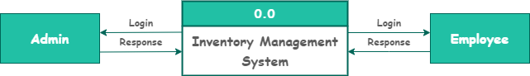**Context Level**

**First – Level**

* + **Admin**

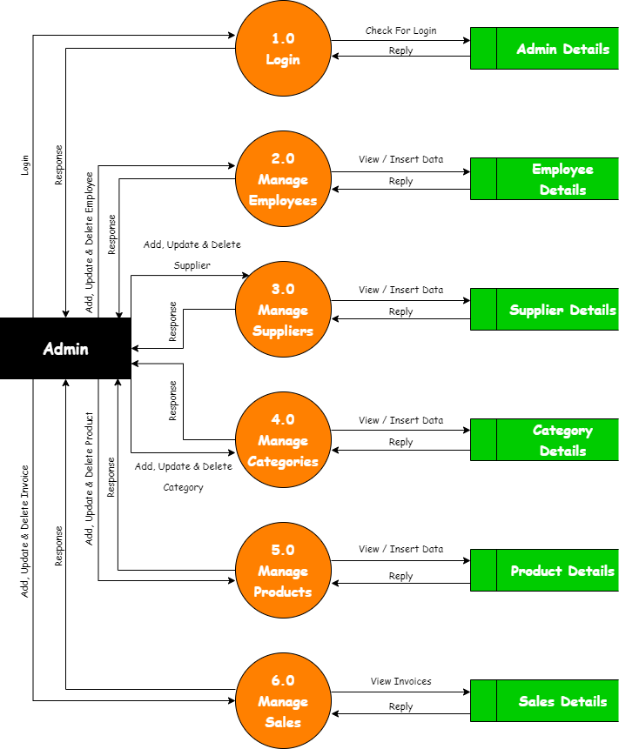

* + **Employee**



**Second – Level**

* + **Admin**

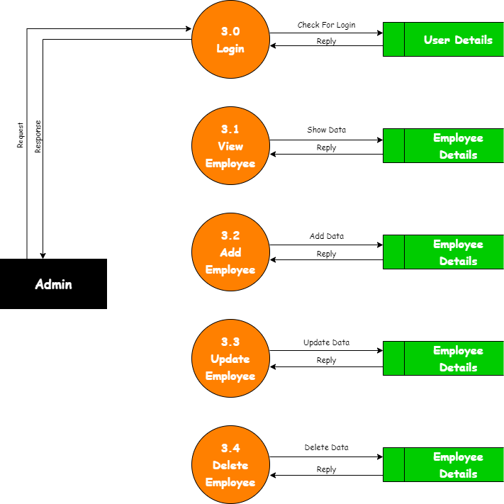

* + **Employee**

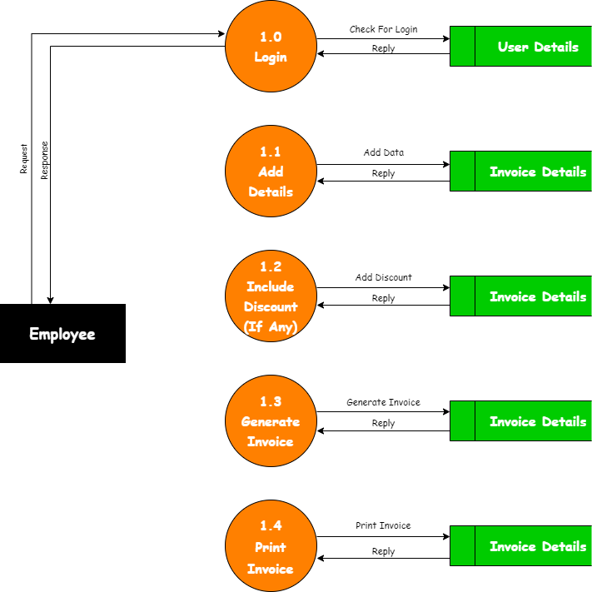

* 1. **E-R Diagram**

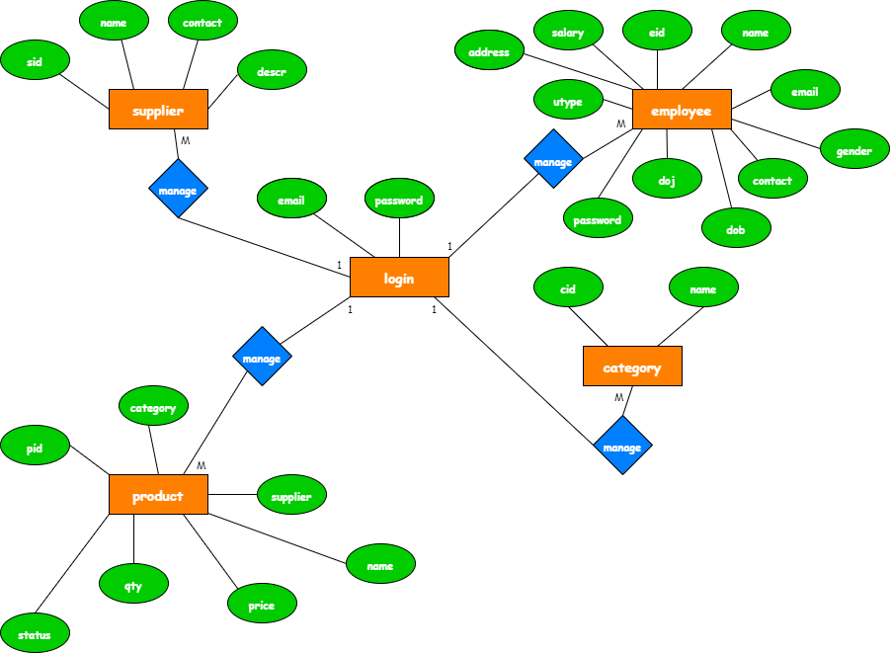

* 1. **Use – Case Diagram**
  + **Admin**

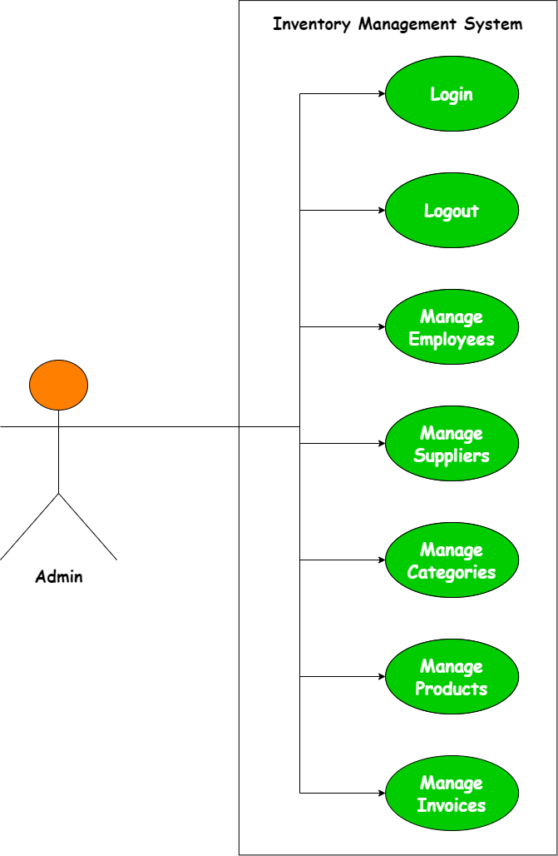

* + 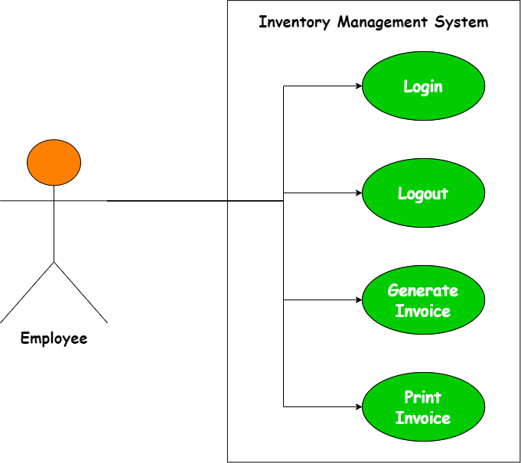**Employee**
  1. **Gantt Chart**

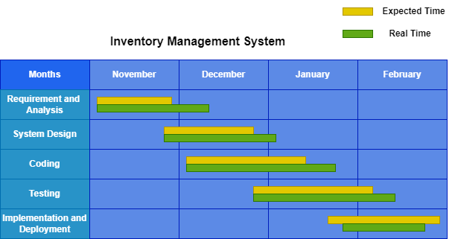

**CHAPTER 5**

**TEST CASES**

1. **Login**

|  |  |  |  |  |  |  |
| --- | --- | --- | --- | --- | --- | --- |
| **TEST CASE** | | | | | | |
| **TEST CASE NO.:** 1 | | | | **TEST CASE DESIGN DATE:** | | |
| 02-Feb-2023 | | |
| **TEST TITLE:** Login Test | | | | **TEST CASE EXAMINATION DATE:** | | |
| 02-Feb-2023 | | |
| **DESCRIPTION:** In this test login form of project will be tested. | | | | | | |
| **PRECONDITION:** Login form must be working. | | | | | | |
| **DEPENDENCIES:** Application framework and database. | | | | | | |
| **STEP NO.** | **TEST STEP** | **TEST DATA** | **EXPECTED RESULT** | **ACTUAL RESULT** | **STATUS (PASS/FAIL)** | **NOTES** |
| 1 | Navigate to login page | Login activity | Login in the page | Login in the page | Pass |  |
| 2 | Enter email and password | abc@xyz.in | Login successful | Invalid email | Fail | Email and password must be authorized |
| 3 | Click login button | Button click | Check credentials | Same as expected | Pass |  |

* 1. **Manage Employees**

|  |  |  |  |  |  |  |
| --- | --- | --- | --- | --- | --- | --- |
| **TEST CASE** | | | | | | |
| **TEST CASE NO.:** 2 | | | | **TEST CASE DESIGN DATE:** | | |
| 02-Feb-2023 | | |
| **TEST TITLE:** Management Test | | | | **TEST CASE EXAMINATION DATE:** | | |
| 02-Feb-2023 | | |
| **DESCRIPTION:** In this test managing the employees will be tested. | | | | | | |
| **PRECONDITION:** Management of employees must be done properly. | | | | | | |
| **DEPENDENCIES:** Application framework and database. | | | | | | |
| **STEP NO.** | **TEST STEP** | **TEST DATA** | **EXPECTED RESULT** | **ACTUAL RESULT** | **STATUS (PASS/FAIL)** | **NOTES** |
| 1 | Navigate to dashboard | Dashboard activity | Open dashboard | Open dashboard | Pass |  |
| 2 | Click button employee | Button click | Open Page | Open Page | Pass |  |
| 3 | Add details | Employee entry | Successfully entered details | This employee id is already assigned, try different | Fail | Id should be not be repeated |
| 4 | Click save | Button click | Employee added successfully | Same as expected | Pass |  |

* 1. **Manage Suppliers**

|  |  |  |  |  |  |  |
| --- | --- | --- | --- | --- | --- | --- |
| **TEST CASE** | | | | | | |
| **TEST CASE NO.:** 3 | | | | **TEST CASE DESIGN DATE:** | | |
| 02-Feb-2023 | | |
| **TEST TITLE:** Management Test | | | | **TEST CASE EXAMINATION DATE:** | | |
| 02-Feb-2023 | | |
| **DESCRIPTION:** In this test managing the suppliers will be tested. | | | | | | |
| **PRECONDITION:** Management of suppliers must be done properly. | | | | | | |
| **DEPENDENCIES:** Application framework and database. | | | | | | |
| **STEP NO.** | **TEST STEP** | **TEST DATA** | **EXPECTED RESULT** | **ACTUAL RESULT** | **STATUS (PASS/FAIL)** | **NOTES** |
| 1 | Navigate to dashboard | Dashboard activity | Open dashboard | Open dashboard | Pass |  |
| 2 | Click button supplier | Button click | Open Page | Open Page | Pass |  |
| 3 | Add details | Supplier entry | Successfully entered details | This supplier id is already assigned, try different | Fail | Id should be not be repeated |
| 4 | Click save | Button click | Supplier added successfully | Same as expected | Pass |  |

* 1. **Manage Categories**

|  |  |  |  |  |  |  |
| --- | --- | --- | --- | --- | --- | --- |
| **TEST CASE** | | | | | | |
| **TEST CASE NO.:** 4 | | | | **TEST CASE DESIGN DATE:** | | |
| 02-Feb-2023 | | |
| **TEST TITLE:** Management Test | | | | **TEST CASE EXAMINATION DATE:** | | |
| 02-Feb-2023 | | |
| **DESCRIPTION:** In this test managing the categories will be tested. | | | | | | |
| **PRECONDITION:** Management of categories must be done properly. | | | | | | |
| **DEPENDENCIES:** Application framework and database. | | | | | | |
| **STEP NO.** | **TEST STEP** | **TEST DATA** | **EXPECTED RESULT** | **ACTUAL RESULT** | **STATUS (PASS/FAIL)** | **NOTES** |
| 1 | Navigate to dashboard | Dashboard activity | Open dashboard | Open dashboard | Pass |  |
| 2 | Click button category | Button click | Open Page | Open Page | Pass |  |
| 3 | Add details | Category entry | Successfully entered details | Category already present, try different | Fail | Category should be not be repeated |
| 4 | Click save | Button click | Category added successfully | Same as expected | Pass |  |

* 1. **Manage Products**

|  |  |  |  |  |  |  |
| --- | --- | --- | --- | --- | --- | --- |
| **TEST CASE** | | | | | | |
| **TEST CASE NO.:** 5 | | | | **TEST CASE DESIGN DATE:** | | |
| 02-Feb-2023 | | |
| **TEST TITLE:** Management Test | | | | **TEST CASE EXAMINATION DATE:** | | |
| 02-Feb-2023 | | |
| **DESCRIPTION:** In this test managing the products will be tested. | | | | | | |
| **PRECONDITION:** Management of products must be done properly. | | | | | | |
| **DEPENDENCIES:** Application framework and database. | | | | | | |
| **STEP NO.** | **TEST STEP** | **TEST DATA** | **EXPECTED RESULT** | **ACTUAL RESULT** | **STATUS (PASS/FAIL)** | **NOTES** |
| 1 | Navigate to dashboard | Dashboard activity | Open dashboard | Open dashboard | Pass |  |
| 2 | Click button product | Button click | Open Page | Open Page | Pass |  |
| 3 | Add details | product entry | Successfully entered details | Product already present, try different | Fail | Product should be not be repeated |
| 4 | Click save | Button click | Product added successfully | Same as expected | Pass |  |

* 1. **Making Invoices**

|  |  |  |  |  |  |  |
| --- | --- | --- | --- | --- | --- | --- |
| **TEST CASE** | | | | | | |
| **TEST CASE NO.:** 6 | | | | **TEST CASE DESIGN DATE:** | | |
| 02-Feb-2023 | | |
| **TEST TITLE:** Invoice generation and printing test | | | | **TEST CASE EXAMINATION DATE:** | | |
| 02-Feb-2023 | | |
| **DESCRIPTION:** In this test generation and printing of invoice will be tested | | | | | | |
| **PRECONDITION:** Generation and printing of invoice must be done properly. | | | | | | |
| **DEPENDENCIES:** Application framework and database. | | | | | | |
| **STEP NO.** | **TEST STEP** | **TEST DATA** | **EXPECTED RESULT** | **ACTUAL RESULT** | **STATUS (PASS/FAIL)** | **NOTES** |
| 1 | Employee Login | Login activity | Open billing page | Open billing page | Pass |  |
| 3 | Add details | Invoice entry | Bill has been generated | Invalid quantity | Fail | Quantity should be there. |
| 4 | Click print | Button click | Bill is printing | Same as expected | Pass |  |

**CHAPTER 6**

**SCREENSHOTS**

* 1. 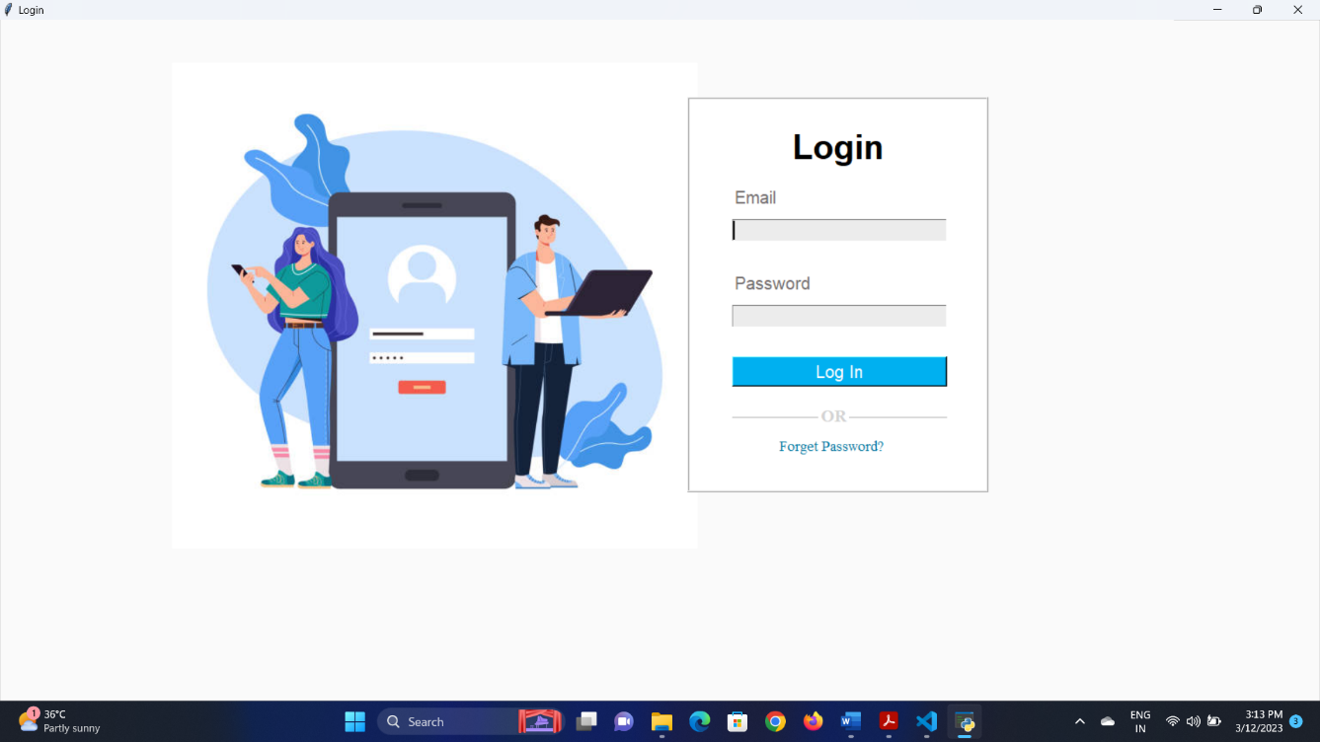**Login Page**
* This is user login page.
  1. 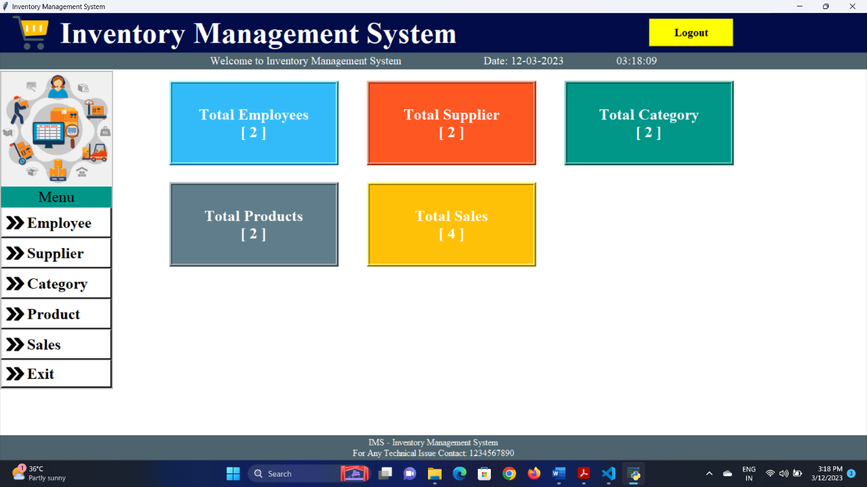**Dashboard**
* This is admin dashboard.
  1. **Employee Page**

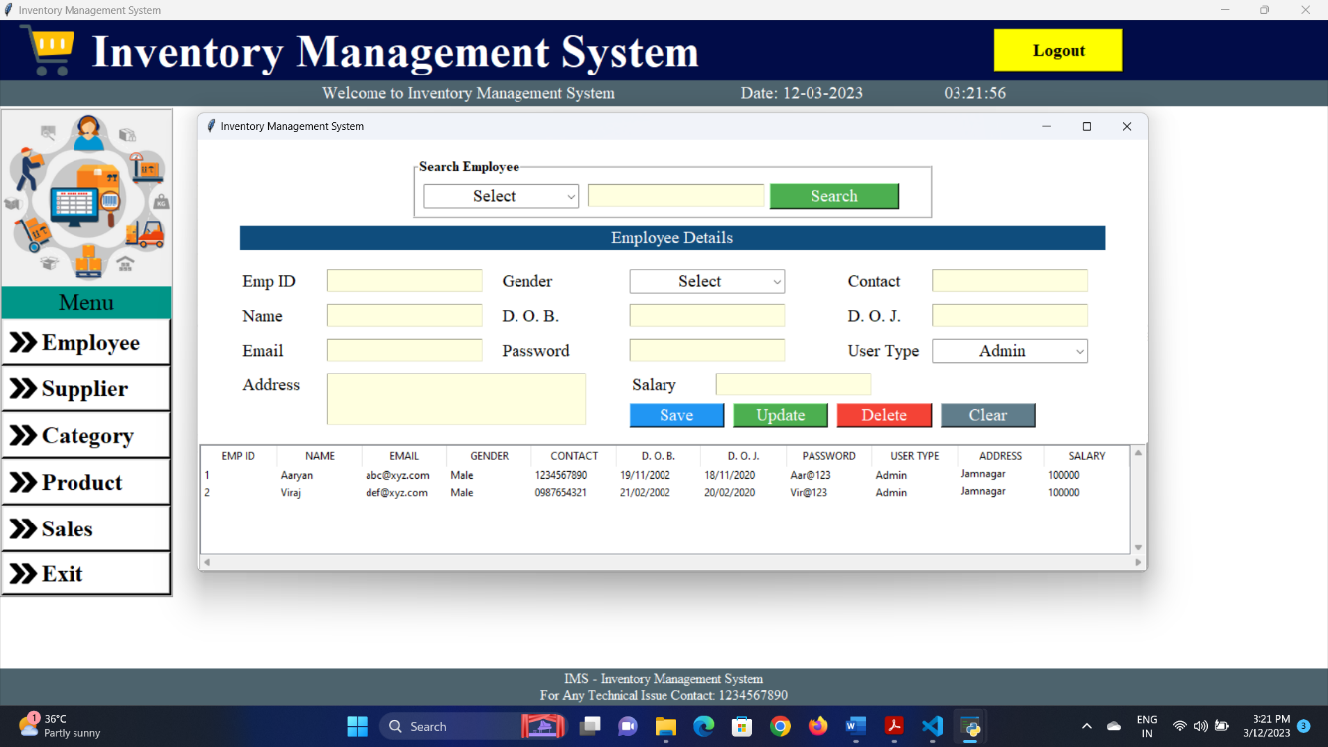

* Admin can manage employees from this page.
  1. **Supplier Page**

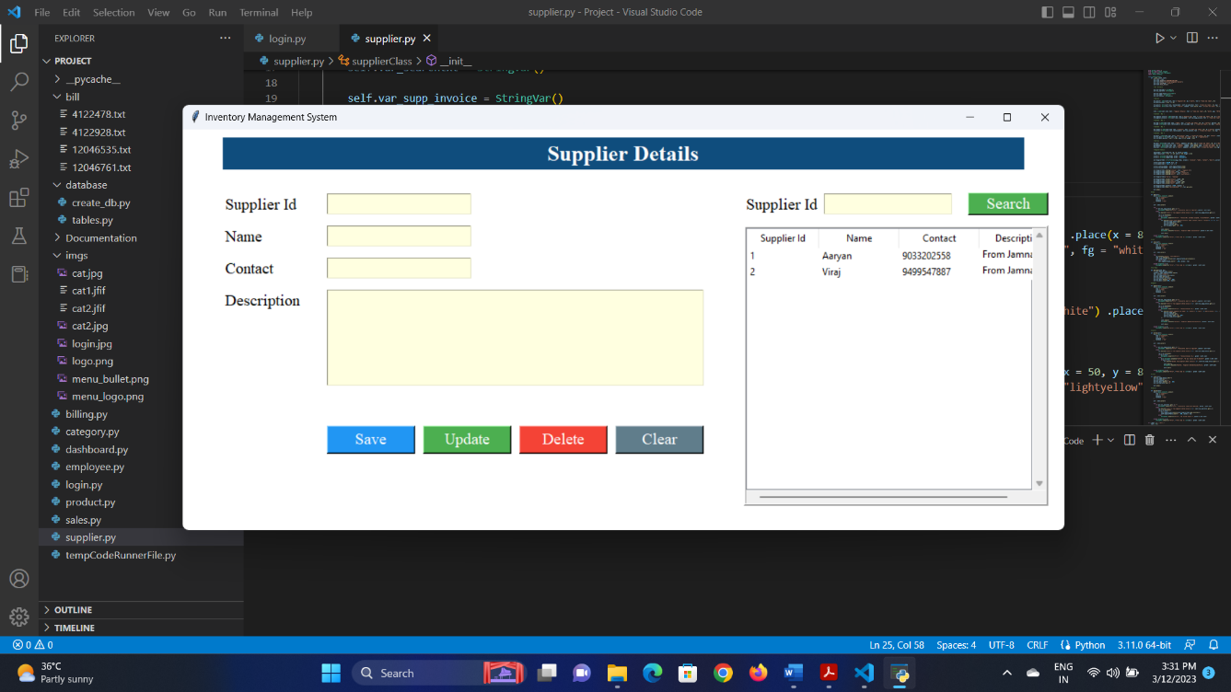

* Admin can manage suppliers from this page.
  1. **Category Page**

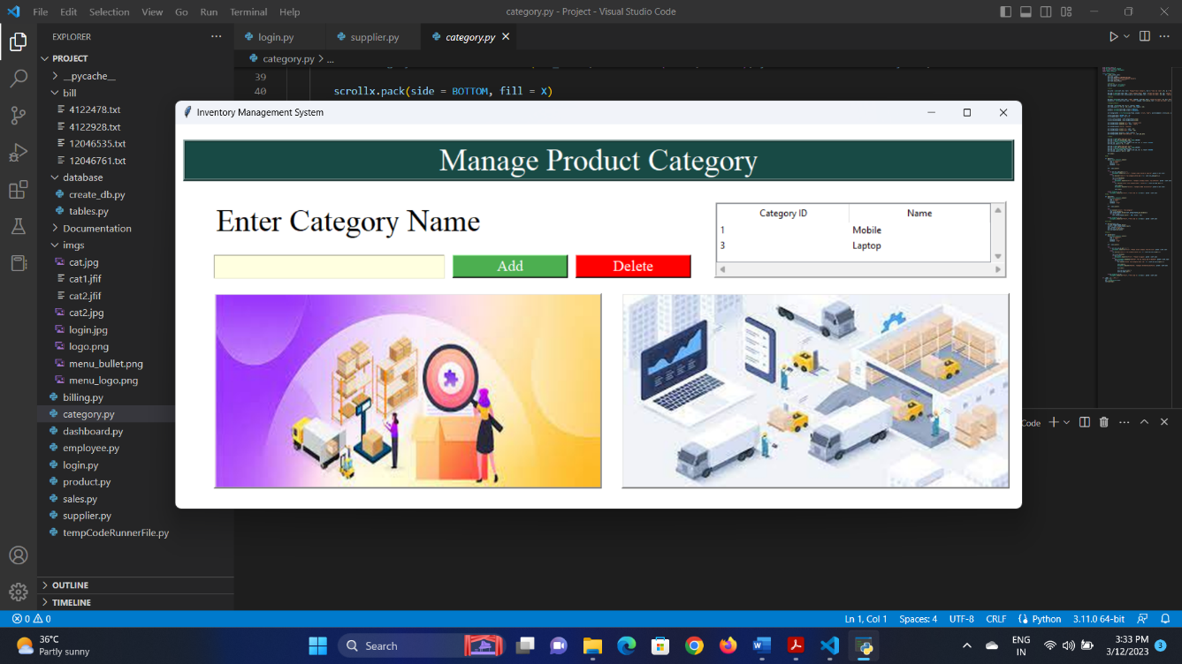

* Admin can manage categories from this page.
  1. **Product Page**

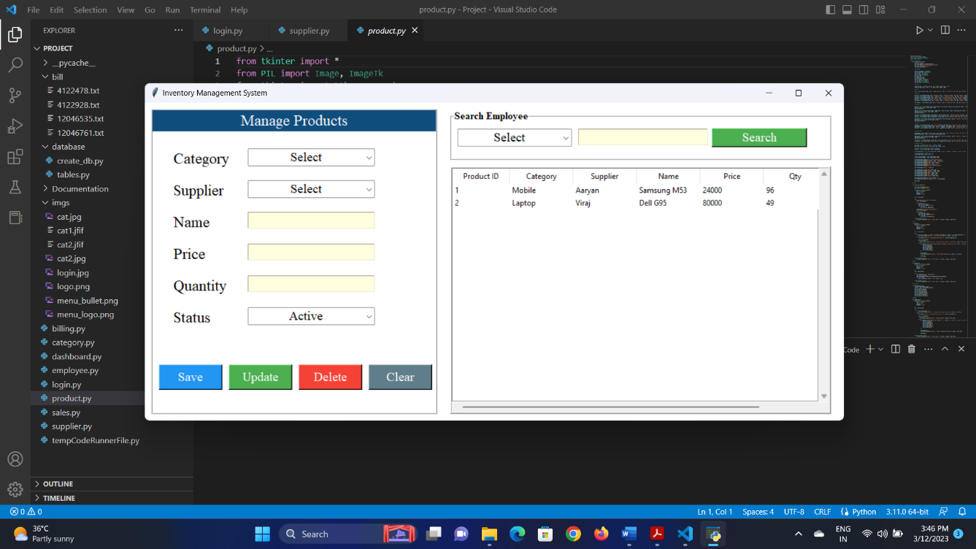

* Admin can manage products from this page.
  1. **Sales Page**

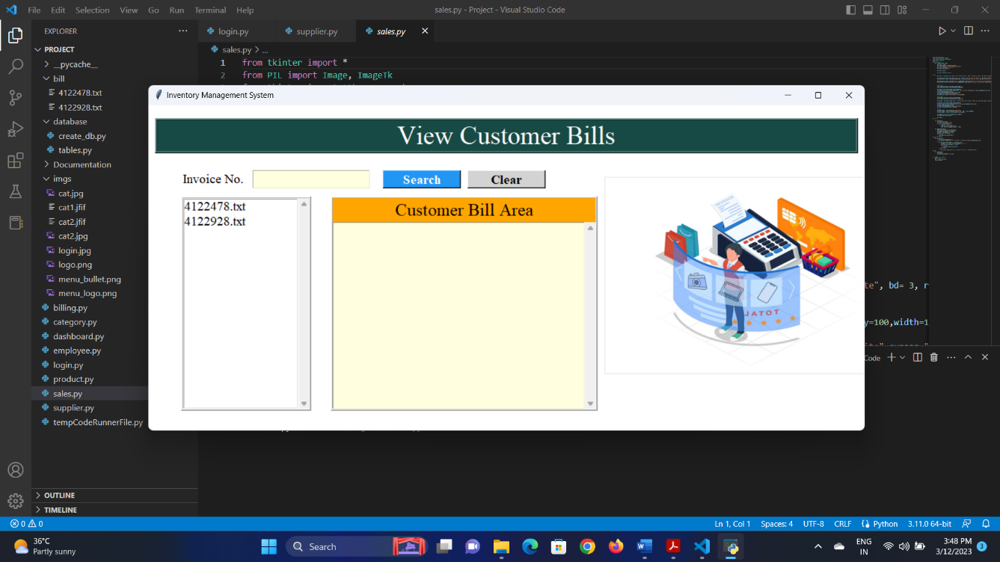

* Admin can manage sales invoices from this page.
  1. **Billing Page**

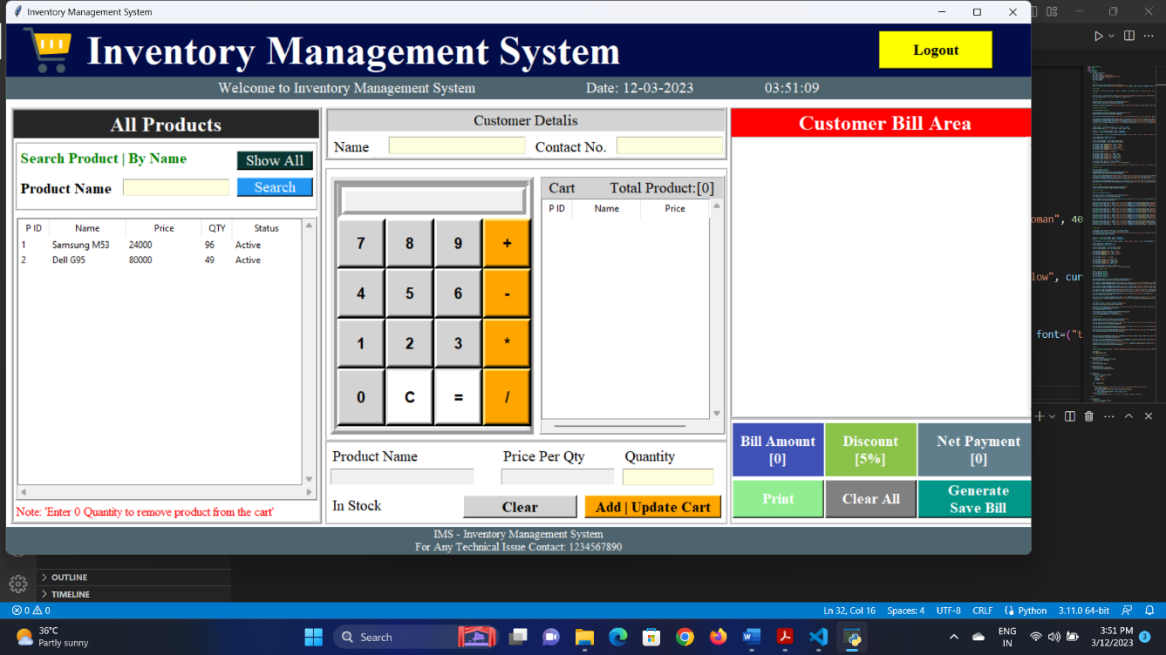

* Employee can generate and print invoice from this page.

**CHAPTER 7**

**LIMITATIONS AND FUTURE ENHANCEMENTS**

* 1. **Limitations**
* Bank account should be maintained manually.
* Only one company can be run at one time.
  1. **Future Enhancements**
* Maintenance of bank account can be done digitally.
* Multiple companies can be run at one time.

**CHAPTER 8**

**CONCLUSION**

* At last **Inventory Management System** is a GUI based web application which allows the owner to maintain complete inventory of his/her firm.
* In this system, admin and employee can login by using their credentials.
* Admin can maintain the whole inventory digitally whereas employee can only generate and print the invoices.

**CHAPTER 9**

**REFERENCES AND BIBLIOGRAPHY**

* All the references listed below were used to develop and design this GUI based web application and were also used for documentation. We are thankful to each and every person who helped us and supported us for this project completion.
  1. **References**
* [www.javatpoint.com](http://www.javatpoint.com)
* [www.youtube.com](http://www.youtube.com)
  1. **Bibliography**
* [www.ttkbootstrap.readthedocs.io](http://www.ttkbootstrap.readthedocs.io)